Github ‘organizations’

# Organizations

You can use organizations to collaborate with an unlimited number of people across many projects at once, while managing access to your data and customizing settings.

Organizations are shared accounts where businesses and open-source projects can collaborate across many projects at once, with sophisticated security and administrative features.

## About organizations

Your team can collaborate on GitHub by using an organization account, which serves as a container for your shared work and gives the work a unique name and brand.

Each person that uses GitHub always signs into a personal account, and multiple personal accounts can collaborate on shared projects by joining the same organization account.

* A subset of these personal accounts can be given the role of organization owner, which allows those people to granularly manage access to the organization's resources using sophisticated security and administrative features. For more information about account types, see "[Types of GitHub accounts](https://docs.github.com/en/get-started/learning-about-github/types-of-github-accounts)."
* You can invite an unlimited number of people to join your organization, then give these organization members a variety of roles that grant different levels of access to the organization and its data. For more information, see "[Roles in an organization](https://docs.github.com/en/organizations/managing-peoples-access-to-your-organization-with-roles/roles-in-an-organization)."
* In addition to managing access to the organization itself, you can separately manage access to your organization's repositories, project boards, and apps. For more information, see "[Repository roles for an organization](https://docs.github.com/en/organizations/managing-access-to-your-organizations-repositories/repository-roles-for-an-organization)", "[Project board permissions for an organization](https://docs.github.com/en/organizations/managing-access-to-your-organizations-project-boards/project-board-permissions-for-an-organization)", and "[Managing access to your organization's apps](https://docs.github.com/en/organizations/managing-access-to-your-organizations-apps)."
* To simplify access management and enhance collaboration, you can create nested teams that reflect your group's structure, with cascading access permissions and mentions. For more information, see "[About teams](https://docs.github.com/en/organizations/organizing-members-into-teams/about-teams)."
* You can configure the organization to meet the unique needs of your group by managing settings, such as restricting the types of repositories that members can create. For more information, see "[Managing organization settings](https://docs.github.com/en/organizations/managing-organization-settings)."
* To harden your organization's security, you can enforce security requirements and review the organization's audit log. For more information, see "[Keeping your organization secure](https://docs.github.com/en/organizations/keeping-your-organization-secure)."
* Projects maintained and managed by one sole organization owner can easily become inaccessible if the organization owner is unreachable. We recommend an organization have at least two people with *owner* permissions to ensure no one will lose access to a project. For more information, see "[Maintaining ownership continuity for your organization](https://docs.github.com/en/organizations/managing-peoples-access-to-your-organization-with-roles/maintaining-ownership-continuity-for-your-organization)."

## About feature availability

All organizations can own an unlimited number of public and private repositories. You can use organizations for free, with GitHub Free, which includes limited features on private repositories. To get the full feature set on private repositories and additional features at the organization level, including SAML single sign-on and improved support coverage, you can upgrade to GitHub Team or GitHub Enterprise Cloud. For more information, see "[GitHub's products](https://docs.github.com/en/get-started/learning-about-github/githubs-products)."

For more information about how you can try GitHub Enterprise Cloud for free, see "[Setting up a trial of GitHub Enterprise Cloud](https://docs.github.com/en/get-started/signing-up-for-github/setting-up-a-trial-of-github-enterprise-cloud)."

# Roles in an organization

Organization owners can assign roles to individuals and teams giving them different sets of permissions in the organization.

To perform any actions on GitHub, such as creating a pull request in a repository or changing an organization's billing settings, a person must have sufficient access to the relevant account or resource. This access is controlled by permissions. A permission is the ability to perform a specific action. For example, the ability to delete an issue is a permission. A role is a set of permissions you can assign to individuals or teams.

1. Repository-level roles give organization members, outside collaborators and teams of people varying levels of access to repositories. For more information, see "[Repository roles for an organization](https://docs.github.com/en/organizations/managing-access-to-your-organizations-repositories/repository-roles-for-an-organization)."
2. Team-level roles are roles that give permissions to manage a team. You can give any individual member of a team the team maintainer role, which gives the member a number of administrative permissions over a team. For more information, see "[Assigning the team maintainer role to a team member](https://docs.github.com/en/organizations/organizing-members-into-teams/assigning-the-team-maintainer-role-to-a-team-member)."
3. Organization-level roles are sets of permissions that can be assigned to individuals or teams to manage an organization and the organization's repositories, teams, and settings. For more information about all the roles available at the organization level, see "[About organization roles](https://docs.github.com/en/organizations/managing-peoples-access-to-your-organization-with-roles/roles-in-an-organization#about-organization-roles)."

## About organization roles

You can assign individuals or teams to a variety of organization-level roles to control your members' access to your organization and its resources. For more details about the individual permissions included in each role, see "[Permissions for organization roles](https://docs.github.com/en/organizations/managing-peoples-access-to-your-organization-with-roles/roles-in-an-organization#permissions-for-organization-roles)."

### Organization owners

Organization owners have complete administrative access to your organization. This role should be limited, but to no less than two people, in your organization. For more information, see "[Maintaining ownership continuity for your organization](https://docs.github.com/en/organizations/managing-peoples-access-to-your-organization-with-roles/maintaining-ownership-continuity-for-your-organization)."

### Organization members

The default, non-administrative role for people in an organization is the organization member. By default, organization members have a number of permissions, including the ability to create repositories and project boards.

### Organization moderators

Moderators are organization members who, in addition to their permissions as members, are allowed to block and unblock non-member contributors, set interaction limits, and hide comments in public repositories owned by the organization. For more information, see "[Managing moderators in your organization](https://docs.github.com/en/organizations/managing-peoples-access-to-your-organization-with-roles/managing-moderators-in-your-organization)."

### Billing managers

Billing managers are users who can manage the billing settings for your organization, such as payment information. This is a useful option if members of your organization don't usually have access to billing resources. For more information, see "[Adding a billing manager to your organization](https://docs.github.com/en/organizations/managing-peoples-access-to-your-organization-with-roles/adding-a-billing-manager-to-your-organization)."

### Security managers

**Note:** The security manager role is in public beta and subject to change.

Security manager is an organization-level role that organization owners can assign to any team in an organization. When applied, it gives every member of the team permissions to manage security alerts and settings across your organization, as well as read permissions for all repositories in the organization.

### GitHub App managers

By default, only organization owners can manage the settings of GitHub Apps owned by an organization. To allow additional users to manage GitHub Apps owned by an organization, an owner can grant them GitHub App manager permissions.

When you designate a user as a GitHub App manager in your organization, you can grant them access to manage the settings of some or all GitHub Apps owned by the organization. For more information, see:

* "[Adding GitHub App managers in your organization](https://docs.github.com/en/articles/adding-github-app-managers-in-your-organization)"
* "[Removing GitHub App managers from your organization](https://docs.github.com/en/articles/removing-github-app-managers-from-your-organization)"

### Outside collaborators

To keep your organization's data secure while allowing access to repositories, you can add outside collaborators. An outside collaborator is a person who has access to one or more organization repositories but is not explicitly a member of the organization, such as a consultant or temporary employee. For more information, see:

* "[Adding outside collaborators to repositories in your organization](https://docs.github.com/en/articles/adding-outside-collaborators-to-repositories-in-your-organization)"
* "[Converting an organization member to an outside collaborator](https://docs.github.com/en/articles/converting-an-organization-member-to-an-outside-collaborator)"
* "[Removing an outside collaborator from an organization repository](https://docs.github.com/en/articles/removing-an-outside-collaborator-from-an-organization-repository)"

## Permissions for organization roles

|  |
| --- |
|  |
| Organization permission | Owners | Members | Moderators | Billing managers | Security managers |
| Create repositories (see "[Restricting repository creation in your organization](https://docs.github.com/en/articles/restricting-repository-creation-in-your-organization)") | **X** | **X** | **X** |  | **X** |
| View and edit billing information | **X** |  |  | **X** |  |
| Invite people to join the organization | **X** |  |  |  |  |
| Edit and cancel invitations to join the organization | **X** |  |  |  |  |
| Remove members from the organization | **X** |  |  |  |  |
| Reinstate former members to the organization | **X** |  |  |  |  |
| Add and remove people from all teams | **X** |  |  |  |  |
| Promote organization members to *team maintainer* | **X** |  |  |  |  |
| Configure code review assignments (see "[Managing code review assignment for your team](https://docs.github.com/en/organizations/organizing-members-into-teams/managing-code-review-assignment-for-your-team)") | **X** |  |  |  |  |
| Set scheduled reminders (see "[Managing scheduled reminders for pull requests](https://docs.github.com/en/github/setting-up-and-managing-organizations-and-teams/managing-scheduled-reminders-for-pull-requests)") | **X** |  |  |  |  |
| Add collaborators to all repositories | **X** |  |  |  |  |
| Access the organization audit log | **X** |  |  |  |  |
| Edit the organization's profile page (see "[About your organization's profile](https://docs.github.com/en/github/setting-up-and-managing-your-github-profile/customizing-your-profile/about-your-organizations-profile)") | **X** |  |  |  |  |
| Delete all teams | **X** |  |  |  |  |
| Delete the organization account, including all repositories | **X** |  |  |  |  |
| Create teams (see "[Setting team creation permissions in your organization](https://docs.github.com/en/articles/setting-team-creation-permissions-in-your-organization)") | **X** | **X** | **X** |  | **X** |
| [Move teams in an organization's hierarchy](https://docs.github.com/en/articles/moving-a-team-in-your-organization-s-hierarchy) | **X** |  |  |  |  |
| Create project boards (see "[Project board permissions for an organization](https://docs.github.com/en/articles/project-board-permissions-for-an-organization)") | **X** | **X** | **X** |  | **X** |
| See all organization members and teams | **X** | **X** | **X** |  | **X** |
| @mention any visible team | **X** | **X** | **X** |  | **X** |
| Can be made a *team maintainer* | **X** | **X** | **X** |  | **X** |
| View and post public team discussions to all teams (see "[About team discussions](https://docs.github.com/en/organizations/collaborating-with-your-team/about-team-discussions)") | **X** | **X** | **X** |  | **X** |
| View and post private team discussions to all teams (see "[About team discussions](https://docs.github.com/en/organizations/collaborating-with-your-team/about-team-discussions)") | **X** |  |  |  |  |
| Edit and delete team discussions in all teams (see "[Managing disruptive comments](https://docs.github.com/en/communities/moderating-comments-and-conversations/managing-disruptive-comments)") | **X** |  |  |  |  |
| Disable team discussions for an organization (see "[Disabling team discussions for your organization](https://docs.github.com/en/articles/disabling-team-discussions-for-your-organization)") | **X** |  |  |  |  |
| Hide comments on writable commits, pull requests, and issues (see "[Managing disruptive comments](https://docs.github.com/en/communities/moderating-comments-and-conversations/managing-disruptive-comments/#hiding-a-comment)") | **X** | **X** | **X** |  | **X** |
| Hide comments on *all* commits, pull requests, and issues (see "[Managing disruptive comments](https://docs.github.com/en/communities/moderating-comments-and-conversations/managing-disruptive-comments/#hiding-a-comment)") | **X** |  | **X** |  | **X** |
| Block and unblock non-member contributors (see "[Blocking a user from your organization](https://docs.github.com/en/communities/maintaining-your-safety-on-github/blocking-a-user-from-your-organization)") | **X** |  | **X** |  |  |
| Limit interactions for certain users in public repositories (see "[Limiting interactions in your organization](https://docs.github.com/en/communities/moderating-comments-and-conversations/limiting-interactions-in-your-organization)") | **X** |  | **X** |  |  |
| Set a team profile picture in all teams (see "[Setting your team's profile picture](https://docs.github.com/en/articles/setting-your-team-s-profile-picture)") | **X** |  |  |  |  |
| Sponsor accounts and manage the organization's sponsorships (see "[Sponsoring open-source contributors](https://docs.github.com/en/sponsors/sponsoring-open-source-contributors)") | **X** |  |  | **X** | **X** |
| Manage email updates from sponsored accounts (see "[Managing updates from accounts your organization's sponsors](https://docs.github.com/en/organizations/managing-organization-settings/managing-updates-from-accounts-your-organization-sponsors)") | **X** |  |  |  |  |
| Attribute your sponsorships to another organization (see "[Attributing sponsorships to your organization](https://docs.github.com/en/sponsors/sponsoring-open-source-contributors/attributing-sponsorships-to-your-organization)" for details ) | **X** |  |  |  |  |
| Manage the publication of GitHub Pages sites from repositories in the organization (see "[Managing the publication of GitHub Pages sites for your organization](https://docs.github.com/en/organizations/managing-organization-settings/managing-the-publication-of-github-pages-sites-for-your-organization)") | **X** |  |  |  |  |
| Manage security and analysis settings (see "[Managing security and analysis settings for your organization](https://docs.github.com/en/organizations/keeping-your-organization-secure/managing-security-and-analysis-settings-for-your-organization)") | **X** |  |  |  | **X** |
| View the security overview for the organization (see "[About the security overview](https://docs.github.com/en/code-security/security-overview/about-the-security-overview)") | **X** |  |  |  | **X** |
| Transfer repositories | **X** |  |  |  |  |
| Purchase, install, manage billing for, and cancel GitHub Marketplace apps | **X** |  |  |  |  |
| List apps in GitHub Marketplace | **X** |  |  |  |  |
| Receive [Dependabot alerts about insecure dependencies](https://docs.github.com/en/code-security/dependabot/dependabot-alerts/about-dependabot-alerts) for all of an organization's repositories | **X** |  |  |  | **X** |
| Manage Dependabot security updates (see "[About Dependabot security updates](https://docs.github.com/en/github/managing-security-vulnerabilities/about-dependabot-security-updates)") | **X** |  |  |  | **X** |
| [Manage the forking policy](https://docs.github.com/en/organizations/managing-organization-settings/managing-the-forking-policy-for-your-organization) | **X** |  |  |  |  |
| [Limit activity in public repositories in an organization](https://docs.github.com/en/communities/moderating-comments-and-conversations/limiting-interactions-in-your-organization) | **X** |  |  |  |  |
| Pull (read) *all repositories* in the organization | **X** |  |  |  | **X** |
| Push (write) and clone (copy) *all repositories* in the organization | **X** |  |  |  |  |
| Convert organization members to [outside collaborators](https://docs.github.com/en/organizations/managing-peoples-access-to-your-organization-with-roles/roles-in-an-organization#outside-collaborators) | **X** |  |  |  |  |
| [View people with access to an organization repository](https://docs.github.com/en/articles/viewing-people-with-access-to-your-repository) | **X** |  |  |  |  |
| Manage the default branch name (see "[Managing the default branch name for repositories in your organization](https://docs.github.com/en/organizations/managing-organization-settings/managing-the-default-branch-name-for-repositories-in-your-organization)") | **X** |  |  |  |  |
| Manage default labels (see "[Managing default labels for repositories in your organization](https://docs.github.com/en/articles/managing-default-labels-for-repositories-in-your-organization)") | **X** |  |  |  |  |
| Manage pull request reviews in the organization (see "[Managing pull request reviews in your organization](https://docs.github.com/en/organizations/managing-organization-settings/managing-pull-request-reviews-in-your-organization)") | **X** |  |  |  |  |

# About teams

Teams are groups of organization members that reflect your company or group's structure with cascading access permissions and mentions.

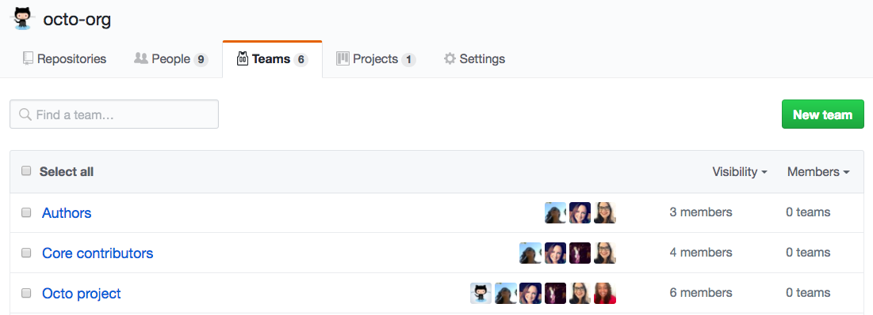

Organization owners and team maintainers can give teams admin, read, or write access to organization repositories. Organization members can send a notification to an entire team by mentioning the team's name. Organization members can also send a notification to an entire team by requesting a review from that team. Organization members can request reviews from specific teams with read access to the repository where the pull request is opened. Teams can be designated as owners of certain types or areas of code in a CODEOWNERS file.

For more information, see:

* "[Managing team access to an organization repository](https://docs.github.com/en/articles/managing-team-access-to-an-organization-repository)"
* "[Mentioning people and teams](https://docs.github.com/en/articles/basic-writing-and-formatting-syntax/#mentioning-people-and-teams)"
* "[About code owners](https://docs.github.com/en/articles/about-code-owners)"

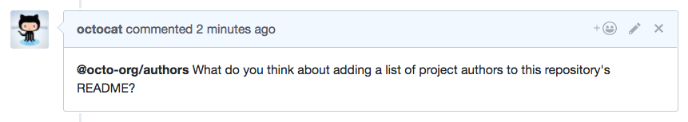

## Team visibility

Teams can be visible or secret:

* Visible teams can be [viewed and @mentioned](https://docs.github.com/en/articles/basic-writing-and-formatting-syntax/#mentioning-people-and-teams) by every organization member.
* Secret teams are only visible to the people on the team and people with owner permissions. They're great for hiding teams with sensitive names or members, such as those used for working with external partners or clients. Secret teams cannot be nested under parent teams or have child teams.

You can view all the teams you belong to on your personal dashboard. For more information, see "[About your personal dashboard](https://docs.github.com/en/account-and-profile/setting-up-and-managing-your-personal-account-on-github/managing-personal-account-settings/about-your-personal-dashboard#finding-your-top-repositories-and-teams)."

## Team pages

Each team has its own page within an organization. On a team's page, you can view team members, child teams, and the team's repositories. Organization owners and team maintainers can access team settings and update the team's description and profile picture from the team's page.

Organization members can create and participate in discussions with the team. For more information, see "[About team discussions](https://docs.github.com/en/organizations/collaborating-with-your-team/about-team-discussions)."

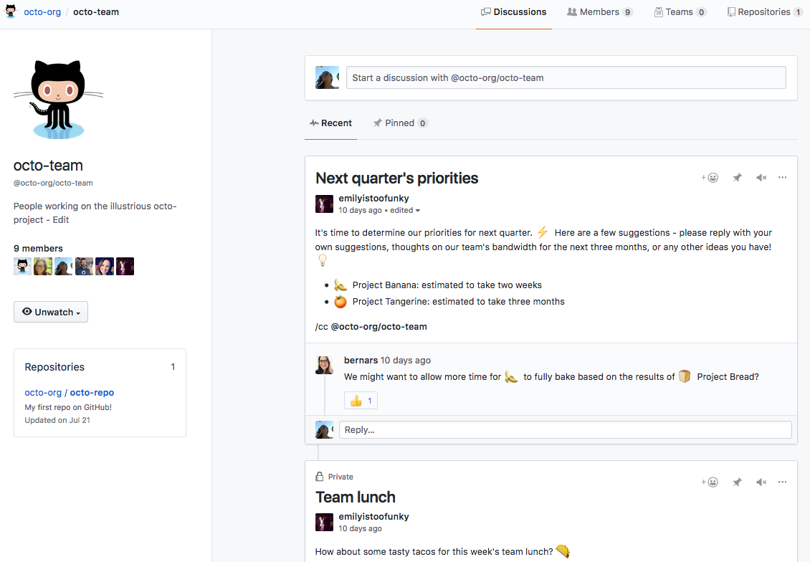

## Nested teams

You can reflect your group or company's hierarchy within your GitHub organization with multiple levels of nested teams. A parent team can have multiple child teams, while each child team only has one parent team. You cannot nest secret teams.

Child teams inherit the parent's access permissions, simplifying permissions management for large groups. Members of child teams also receive notifications when the parent team is @mentioned, simplifying communication with multiple groups of people.

For example, if your team structure is Employees > Engineering > Application Engineering > Identity, granting Engineering write access to a repository means Application Engineering and Identity also get that access. If you @mention the Identity Team or any team at the bottom of the organization hierarchy, they're the only ones who will receive a notification.

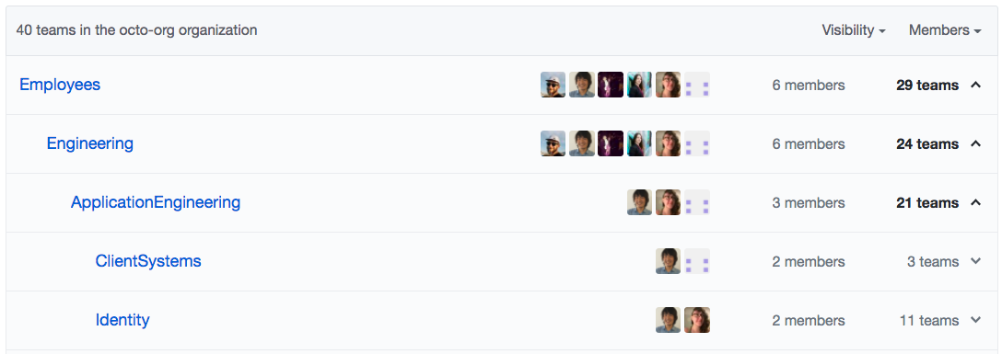

To easily understand who shares a parent team's permissions and mentions, you can see all of the members of a parent team's child teams on the Members tab of the parent team's page. Members of a child team are not direct members of the parent team.

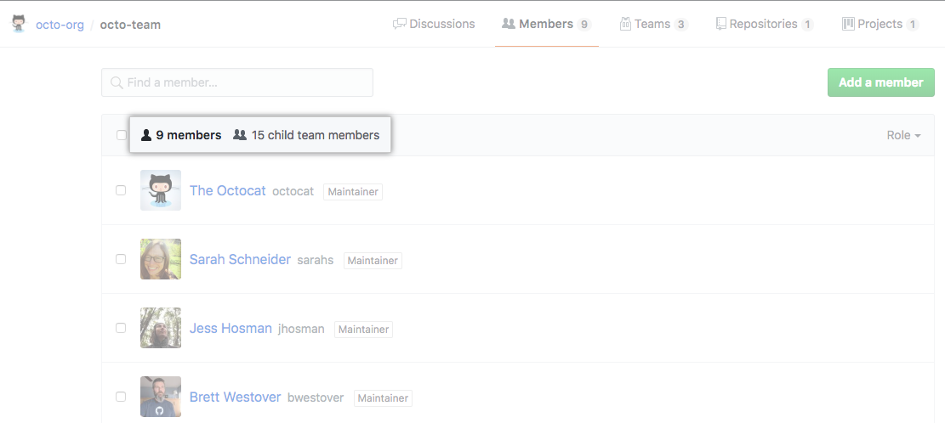

You can choose a parent when you create the team, or you can move a team in your organization's hierarchy later. For more information see, "[Moving a team in your organization’s hierarchy](https://docs.github.com/en/articles/moving-a-team-in-your-organization-s-hierarchy)."

## Preparing to nest teams in your organization

If your organization already has existing teams, you should audit each team's repository access permissions before you nest teams above or below it. You should also consider the new structure you'd like to implement for your organization.

At the top of the team hierarchy, you should give parent teams repository access permissions that are safe for every member of the parent team and its child teams. As you move toward the bottom of the hierarchy, you can grant child teams additional, more granular access to more sensitive repositories.

1. Remove all members from existing teams
2. Audit and adjust each team's repository access permissions and give each team a parent
3. Create any new teams you'd like to, choose a parent for each new team, and give them repository access
4. Add people directly to teams